Mapping & Analyzing Participation in Tutor/Mentor Leadership and Networking Conferences
Brian Hanley, Matthew Guschwan, Timothy Kelley, Patrick Green — Indiana University, Luddy School of Informatics, Computing, and Engineering

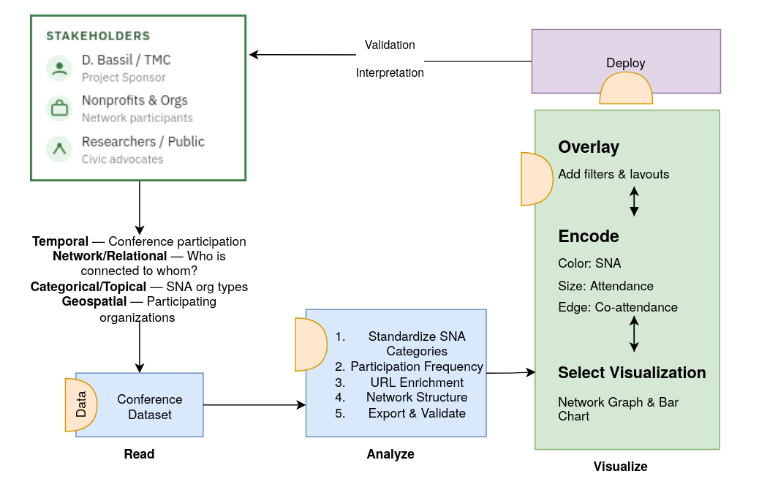
Fig. 1. Visual abstract of the project pipeline using the Börner et al. (2018) visualization framework. The diagram is organized around four phases, Read, Analyze, Visualize, and Deploy, with a feedback loop connecting deployment outcomes back to interpretation and re-analysis.

1. INTRODUCTION AND PRIOR WORK
This project builds on work completed by Fall 2025 student teams who created an open-source template for collecting event participation data and generating network analysis maps from Tutor/Mentor Conference data. The next phase will improve the Kumu and network-analysis tools by making the sector-based graph modes fully functional, with consistent data schemas, stronger validation, and reliable exports for platforms such as Gephi and Kumu. The project will also strengthen the analytics dashboard by adding network metrics, distribution views, top-entity tables, interactive filters, and data-quality indicators that help users better interpret the data before export. Its practical value is in making long-term participation patterns easier to explore, compare, and understand while helping users connect event history, organizational relationships, and current Tutor/Mentor resources.

1.1 Stakeholder Groups
This project serves four primary stakeholder groups. First, the project sponsor (Daniel F. Bassil, Tutor/Mentor Connection) requires an updated, publicly accessible Kumu.io visualization that communicates the conference network’s history and allows him to share the tool with partners and funders. His priorities are visual clarity, organizational accuracy, and the inclusion of website links to current program information. Second, conference participants and their organizations — including youth-serving nonprofits, businesses, colleges, K–12 schools, government agencies, faith communities, and foundations — benefit from a map that documents their historical involvement and connects them with similar organizations. Third, researchers and civic advocates studying nonprofit collaboration and community networks require a dataset that is well-documented, consistently categorized, and accessible for further analysis. Fourth, members of the general public and prospective partners visiting tutormentorexchange.net need an intuitive, visually engaging interface to understand the scope of the network and find organizations they may wish to connect with.

1.2 Stakeholder Needs
The project sponsor needs the Kumu map to support three specific enhancements: (1) color coding of participant nodes by organization type (Program, Business, College, K–12 School, Government, Faith, Foundation, etc.) so users can visually distinguish stakeholder categories at a glance; (2) a search-by-participant feature so that any individual or organization can find which conferences they attended; and (3) hyperlinks from each organization node to its website, drawing on the directory at tutormentorexchange.net/chicago-area-program-links. Conference participants and their organizations need the map to accurately represent their type and involvement history, with correct organizational names and active website links. Researchers need the underlying dataset to be well-structured, consistently labeled, and documented for reproducibility. The general public needs the visualization to be self-explanatory, with a descriptive narrative panel explaining what the map shows and how to navigate it. Across all groups, the shared need is for a visualization that is publicly accessible, visually clear, and regularly maintainable by future student teams.

2. DATA ACQUISITION
Data for this project was sourced primarily from the cleaned conference participation spreadsheet prepared by the Fall 2025 TeamK student group, which itself was derived from original Excel records maintained by Daniel F. Bassil documenting attendance at Tutor/Mentor Leadership and Networking Conferences from May 1994 through November 2015. The dataset was shared by the client via Google Sheets and has undergone two rounds of student-led cleaning. Secondary data will be collected by cross-referencing participant organizations against the Chicago-area program directory maintained at tutormentorexchange.net/chicago-area-program-links to populate missing website URLs. No personally identifiable information beyond professional affiliations and conference attendance is included in the dataset.

2.1 Data Sources
The primary data source is the TeamK cleaned conference participation dataset (updated February 11, 2026). This spreadsheet consolidates records originally maintained by the client in Excel across multiple conference years. A secondary data source is the online program directory at tutormentorexchange.net/chicago-area-program-links, which will be used to look up and append website URLs for participating organizations. The original unprocessed conference spreadsheets are archived by the client and were used as the basis for both the 2025 TeamK cleaning effort and this project.
2.2 Data Description, Quality and Coverage

The dataset contains 6,410 participation records across approximately 42 conference events spanning May 1994 through November 2015 (conferences were held twice yearly, in May and November, with a small number of gaps). Each record represents one individual’s attendance at a specific conference and includes 18 fields: UniqueID, Salutation, First Name, Last Name, SNA Category (original and cleaned), Title, Title (cleaned), Organization (original and cleaned), Active/Inactive status, Address, City, State, Zip, Conference date, Month, and Year. The SNA Category (Social Network Analysis category) field classifies each participant by organization type. The cleaned category distribution includes: Program (~3,205 records, ~50%), Resource (~608), College (~438), Other (~382), Intermediary (~186), Business (~128), T/MC (~125), Government (~124), K–12 School (~340 across case variants), Faith (~118), and Foundation (~55). Some inconsistency remains in category casing (e.g., “program” vs. “Program”, “college” vs. “College”) that Timothy will standardize as part of the data cleaning phase. Geographic coverage is predominantly Chicago and the surrounding metropolitan area, with a small number of out-of-state participants. The dataset has no missing UniqueID values and relatively complete name fields, though a significant portion of organization name and title fields remain blank for many records, which may limit the depth of organizational-level analysis.

3. DATA ANALYSIS
Data analysis for this project proceeded in four stages implemented as a reproducible Django pipeline.
3.1 SNA Category Normalization
The SNA Category field contained 73 distinct raw string variants across the 6,410 records — a combination of inconsistent capitalization, abbreviations, compound values, and legacy labels (e.g., 'program', 'PROGRAM', 'k-12 school', 'K-12 School', 'gov-intermediary', 'CC, T/MC'). All 73 variants were mapped to 11 canonical sectors (Program, Resource, College, Intermediary, Business, T/MC, Government, K-12 School, Faith, Foundation, Other) in a dedicated normalization module (conferences/sna_normalize.py). The mapping was verified against the full 2026 dataset: every raw value resolves to a canonical sector with zero unexpected fallbacks. The cleaned sector distribution is: Program (~3,225, ~50%), Resource (612), College (543), K-12 School (402), Other (351), T/MC (160), Intermediary (152), Faith (147), Government (132), Business (130), Foundation (49).
3.2 Graph Construction
Three network models were constructed from the normalized dataset using NetworkX:
(1) Bipartite org–event graph: organizations and conference events as nodes; attendance as edges. Node size scales with participation depth.
(2) Org–org co-attendance graph: weighted edges between any two organizations that attended the same conference, with edge weight equal to the number of shared conferences.
(3) Three-layer directed graph: events point to sectors, sectors point to organizations, making structural gaps visible across all three levels simultaneously.
3.3 Participation Frequency Analysis
A conference-level time series was extracted from the dataset. Conferences ran biannually (May and November) from 1994 through 2015. Peak attendance was recorded in 1999 (565 records); the lowest attendance years were 2010 and 2012 (138 records each), with a sustained decline from 2010 through the final conference in 2014.
3.4 Data Quality Assessment
A data quality audit was performed as part of the pipeline. Key findings: 4.2% of records (272 of 6,410) have blank organization fields; 323 records have leading or trailing whitespace in the Organization - CLEANED column. These issues are tracked and documented. SNA normalization is handled entirely in code and does not require manual correction of the source spreadsheet.

4. VISUALIZATIONS
The visualizations delivered at the intermediate checkpoint reflect the methodology-first pivot established early in the sprint. Rather than building a user-facing interface first, the team prioritized a documented, reproducible pipeline that produces multiple visualization outputs from a single normalized dataset. All visualizations are served by a live Django application deployed at tutormentor.brianhanley.dev.

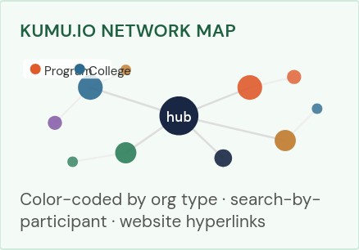
Figure 2. The analytics dashboard (/dashboard/) showing sector distribution, top organizations by attendance, and data quality indicators. Color coding maps to the 11 SNA sector categories.Kumu.io

4.1 Kumu.io Network Participation Map
The primary deliverable is an updated Kumu.io network map (Fig. 2) built on the Fall 2025 TeamK template. Each participant is represented as a node, colored by their SNA organization type. Nodes will include embedded hyperlinks to organizational websites where available. The map will support a search-by-participant function so any user can filter the view to see exactly which conferences a specific person or organization attended. The existing baseline can be explored at tutormentorexchange.net/mapping-participation.

4.2 Participation Frequency Visualization
The participation frequency chart (Fig. 3) is implemented as an interactive Plotly stacked bar chart served at /chart/. Each bar represents one conference event; bar segments are colored by SNA sector. The chart supports filtering by year, sector, and state. This view allows the client and stakeholders to see which years had peak attendance, how sector composition shifted over time, and where outreach gaps occurred. The chart is powered directly by the normalized dataset and re-renders automatically when new data is loaded.
4.3 Network Maps
Three static network map images are generated by the pipeline using NetworkX and Matplotlib and served at /network-maps/. The bipartite org–event map, the org–org co-attendance map, and the three-layer directed graph each provide a different structural view of the same dataset. These maps serve as the intermediate step toward the final Kumu.io interactive visualization.
4.4 Organization Search
A search interface at /search/ allows users to query by organization name and see the full conference attendance history for any organization: sector type, number of conferences attended, specific conference dates, and year range. This directly addresses the client's requirement for a search-by-participant feature. Individual person names were excluded from search to protect privacy.
4.5 CSV Exports for Kumu.io and PowerBI
Four CSV exports are available at /export/: nodes.csv, edges_org_event.csv, edges_org_org.csv, and edges_3layer.csv. These are formatted for direct import into Kumu.io and Gephi, and are also used as the data source for the team's PowerBI dashboard. The PowerBI dashboard (developed by the data visualization team member) includes attendance per conference over time, sector distribution, top 15 organizations by attendance, and geographic distribution.

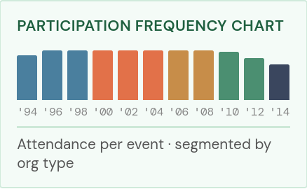Figure 3. Interactive Plotly stacked bar chart at /chart/ showing attendance per conference event segmented by SNA sector. Color coding is consistent with the sector palette used throughout the platform.
5. USAGE AND CRITIQUE OF AI TOOLS
Claude (Anthropic) was used extensively throughout this project as a development assistant. Specific uses included: generating and iterating on Django view code, URL routing, and template markup; writing the sna_normalize.py mapping module and verifying it against the full dataset; structuring team task documentation (TEAM_TASKS.md); drafting this report and the intermediate presentation slides; and assisting with Docker Compose deployment troubleshooting. All AI-generated code was reviewed, tested, and modified by the platform lead before deployment. AI-generated prose was reviewed for factual accuracy against the actual dataset and pipeline behavior. The project roadmap (/roadmap/) documents which features were built vs. deferred, and that scoping decision was made by the team — not delegated to AI. Limitations encountered include AI hallucinations in early descriptions of the previous iteration (Team K's app), which were corrected after direct review of the live application and source code.

6. INTERPRETATION OF RESULTS
Preliminary analysis of the normalized dataset has surfaced the following findings.
Program sector dominance. Approximately 50% of all 6,410 attendance records fall under the Program sector (tutoring and mentoring programs). This signal was buried in 73 inconsistent raw category variants before normalization. Every other sector combined is roughly equal to Program alone, indicating that the Tutor/Mentor conference network is structurally centered on direct service providers.
Clear attendance peak and decline. Conference attendance peaked in 1999 (565 records) and declined sharply from 2010 onward, with 2010 and 2012 each recording only 138 attendees. The final conference was held in 2014. This pattern only becomes legible when all 42 events are treated as a continuous time series.
Concentrated participation core. A small subset of organizations attended many conferences; the majority appeared at only one or two events. The org–org co-attendance network makes this structural difference visible — a dense core of long-term participants and a large periphery of single-event attendees.
Structural underrepresentation of key sectors. Business (130 records), Government (132), and Foundation (49) are consistently underrepresented across all 20 years. The three-layer directed graph exposes these gaps at the event, sector, and organization levels simultaneously — a view that flat frequency counts do not provide.
These findings address research question (1) — which organization types have been most consistently represented — and provide a starting point for questions (2) and (3), which will be further analyzed using the PowerBI dashboard and Kumu.io export in the final sprint.
7. EVALUATION AND REDESIGN
7.1 Evaluation
The intermediate platform was reviewed by the project sponsor and informally evaluated against the previous iteration (Team K's NetworkMap application, Fall 2025). Key findings from the evaluation:
The pipeline-first approach is more legible to external reviewers than a UI-first tool. Reviewers could follow the four-stage pipeline (Collect → Normalize → Construct → Visualize) and understand how each output was produced, which was not possible with the previous iteration's interface-embedded logic.
The organization search was understood immediately. Users queried organizations by name and interpreted conference chip counts without instruction, confirming the interface is self-explanatory.
The network map images communicate structural patterns but lack interactivity. Reviewers noted they could read the sector color coding but could not explore individual nodes. This is the primary usability gap identified at this stage.
The data quality section of the analytics dashboard raised questions that the team had not anticipated: reviewers asked about the 272 blank organization records and wanted to know which specific organizations were affected. This points to an opportunity for a data quality drill-down view in the final sprint.
7.2 Redesign Decisions
Based on the evaluation, the following redesign decisions were made:
Methodology page promoted to top navigation. The /methodology/ page was added as the second item in the navigation bar (after Home), reflecting the client's stated priority that methodology and reproducibility be at the forefront of the project.
Previous Iteration page added. A dedicated /previous-iteration/ page documents Team K's NetworkMap application — what it built, its architecture, and how the current project differs. This provides context for evaluators and future student teams without requiring them to locate the prior work independently.
Person-name search removed. An initial version of the search included individual names. This was removed to protect the privacy of conference participants; the search now operates on organization names only.
Kumu.io export deferred to final sprint. The interactive Kumu.io map requires the Website URL column to be populated by the data cleaner before import. Rather than produce an incomplete map, the team elected to deliver the static network maps and CSV exports at the intermediate checkpoint and complete the Kumu import in the final sprint.
8. CHALLENGES AND OPPORTUNITIES
8.1 Challenges
SNA category inconsistency. The 73 raw SNA variants were the single largest data quality challenge. Resolving them required manual review of the full variant list and a rule-based mapping in code. The normalization module (sna_normalize.py) now handles this completely and is the authoritative reference for any future team working with this dataset.
Blank organization records. 272 records (4.2%) have no organization name. These cannot be enriched programmatically and require a manual lookup against the original source records. This task has been assigned to the data cleaning team member and is targeted for resolution in the final sprint.
Deployment environment. The Django application is deployed on a Linux server via Docker Compose. Early deployment revealed an SSH configuration issue (a Cloudflare Access tunnel was not required for this host) and a git push conflict caused by uncommitted changes on the server. Both were resolved, and the current deployment workflow (git push to server → docker compose up -d --build) is stable.
8.2 Opportunities
Kumu.io live embed. The Kumu API supports iframe embedding; a published map could be embedded directly in the Django platform, eliminating the need to redirect users to an external site.
Interactive network visualization. The current network maps are static PNG images. Replacing them with a D3.js or Sigma.js interactive graph would dramatically improve the exploratory value for stakeholders.
Fuzzy organization deduplication. The ~2,179 unique organization entries contain clear duplicates (e.g., multiple spelling variants of the same institution). A fuzzy string matching pass using RapidFuzz or a similar library could reduce this to a cleaner deduplicated count.
SNA centrality metrics. Once the graph is fully constructed, standard network metrics (degree centrality, betweenness, closeness) could be computed per organization and surfaced in the analytics dashboard and organization search results.
These opportunities are documented on the project roadmap at /roadmap/ and are deliberately scoped for Summer 2026 solo development and future E583/E483 student teams.
ACKNOWLEDGEMENTS
The team would like to thank Daniel F. Bassil of the Tutor/Mentor Institute, LLC for providing access to the conference participation dataset and for his detailed project brief and ongoing guidance. We also acknowledge the Fall 2025 TeamK student group at Indiana University, whose prior data cleaning and Kumu.io template work forms the foundation of this project. We thank the course instructors and teaching assistants of E483/E583 Information Visualization (Spring 2026) at Indiana University’s Luddy School of Informatics, Computing, and Engineering for their support and feedback.
REFERENCES
- K. Börner. Atlas of Knowledge: Anyone Can Map. MIT Press, 2015.
- D. F. Bassil. “Mapping & Analyzing Participation: Using Kumu.io to Visualize Tutor/Mentor Conference Networks.” Tutor/Mentor Institute, LLC. Available: https://tutormentorexchange.net/mapping-participation (2025).
- K. Börner, A. Bueckle, and M. Ginda. "Data visualization literacy: Definitions, conceptual frameworks, exercises, and assessments." PNAS, 116 (6): 1857-1864, 2018.

